Step 1 ending part:

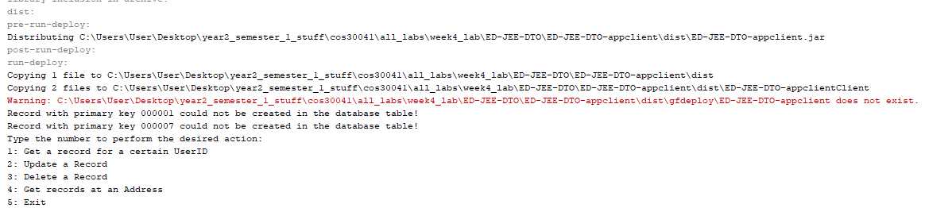

Step 2 all parts:

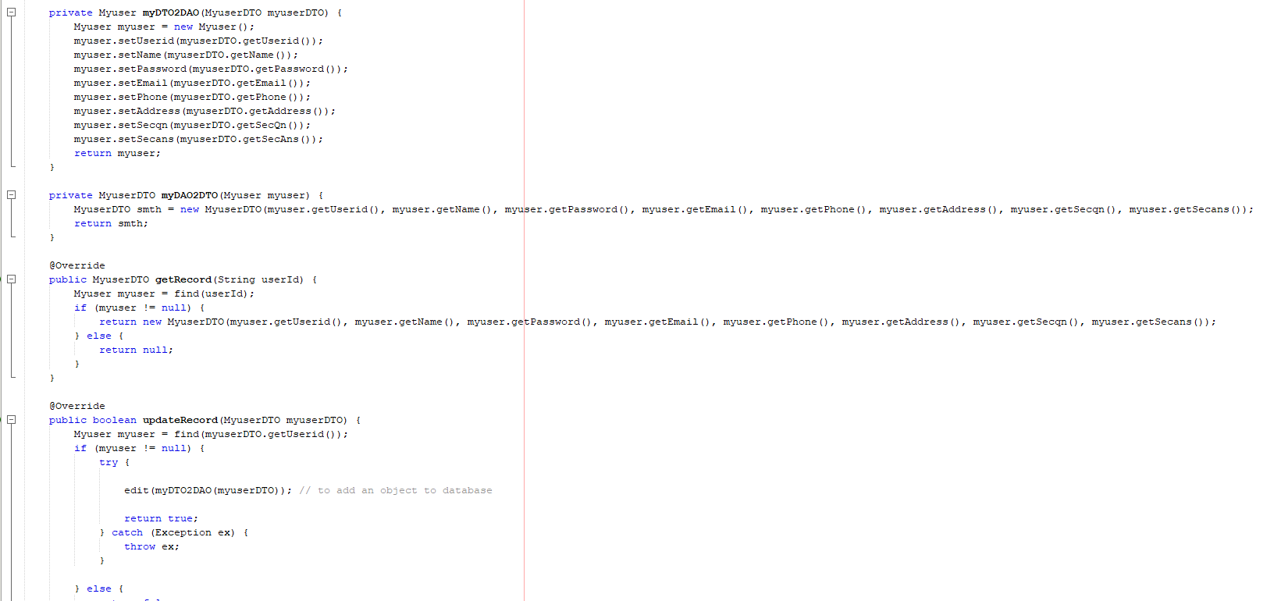

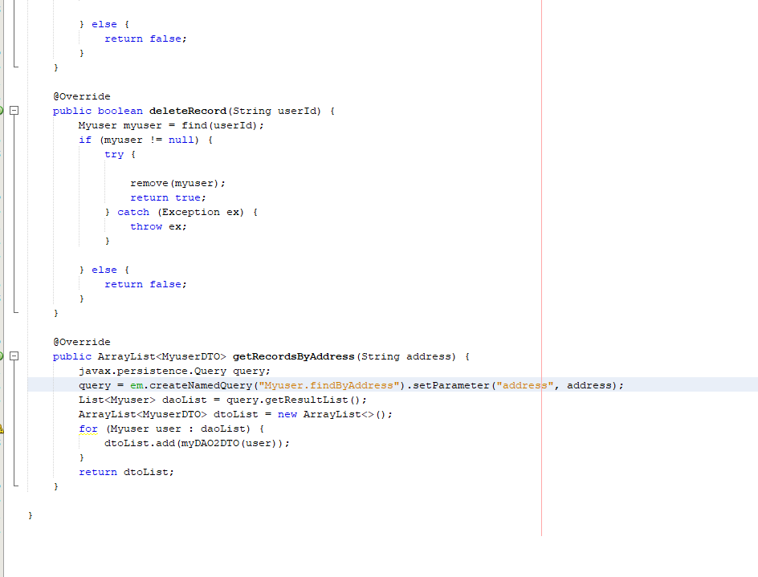

{Note: here my mistake has been I had written findby here instead of findBy for the address part. Thus the program couldn’t understand what I was aksing it to do as the rest of the named queries given in myuser were using findBy and not findby}

Step 3 all code parts:

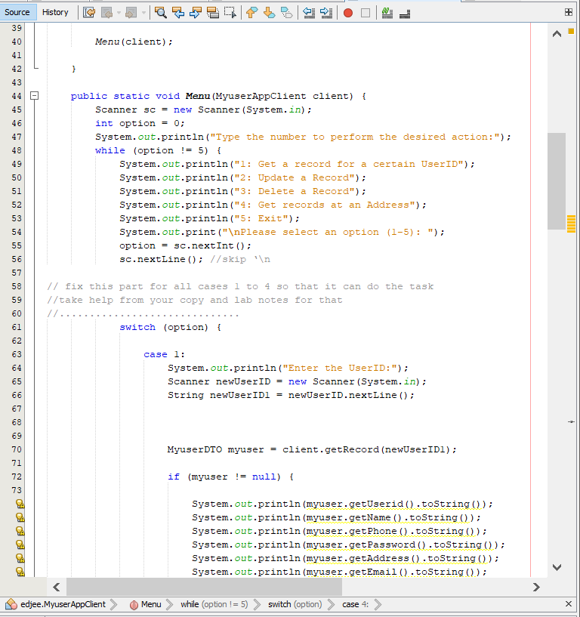

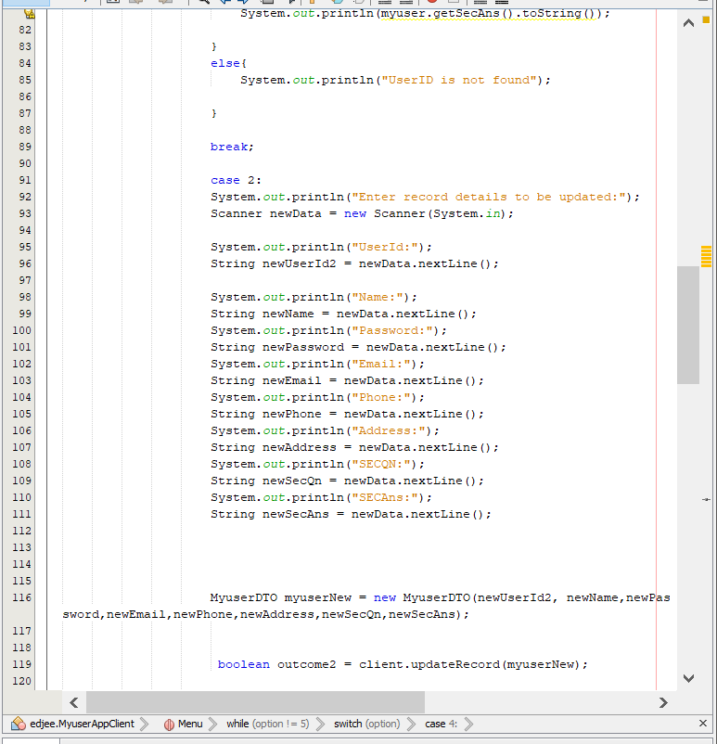

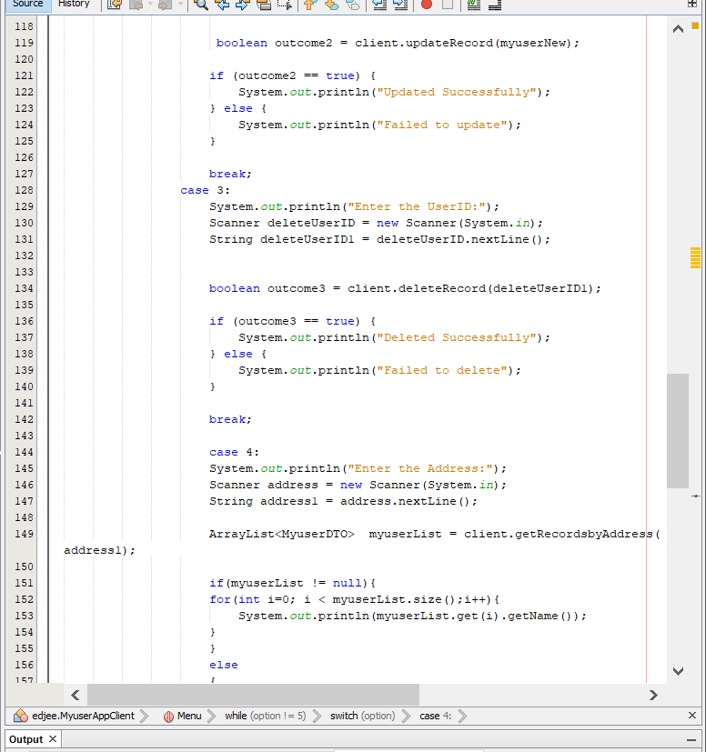

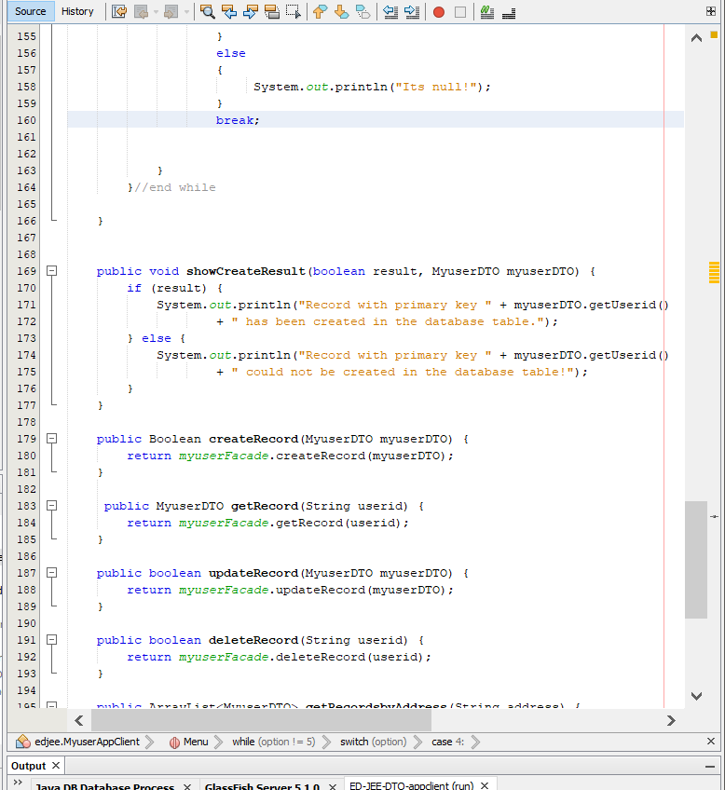

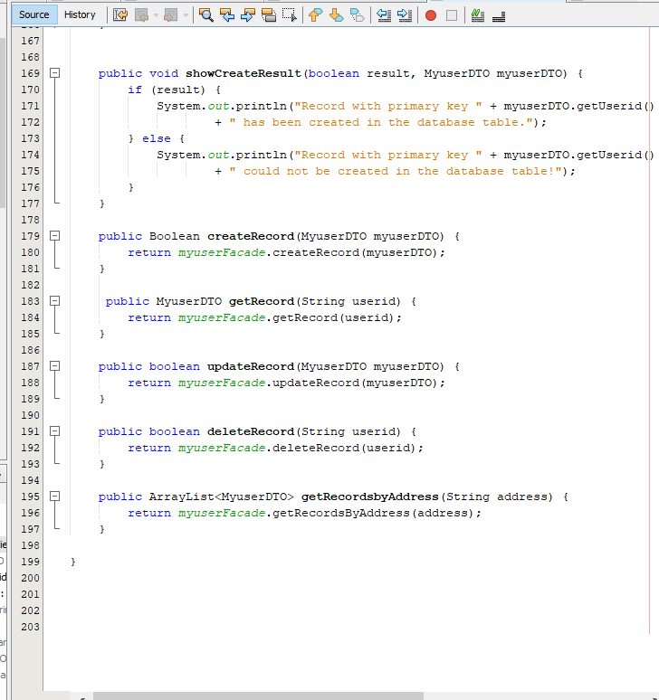

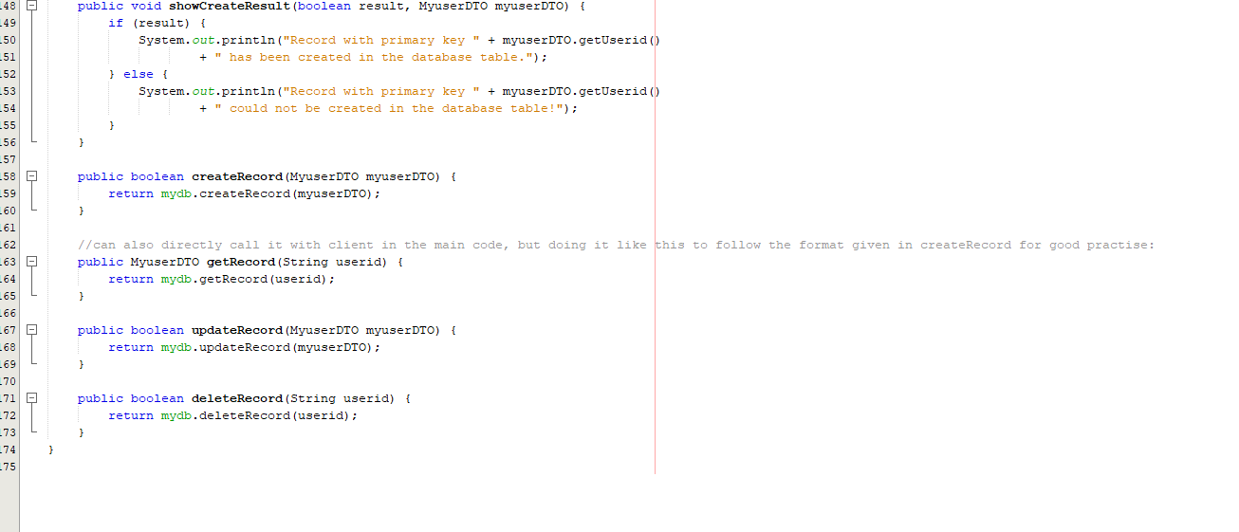

Step 3 outputs:

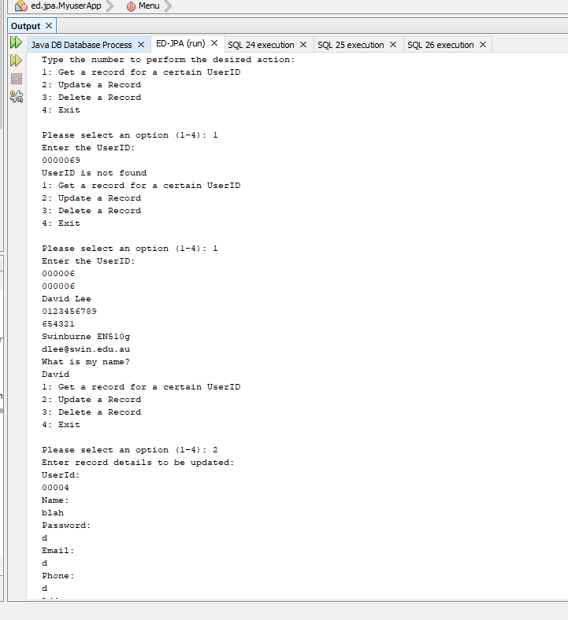

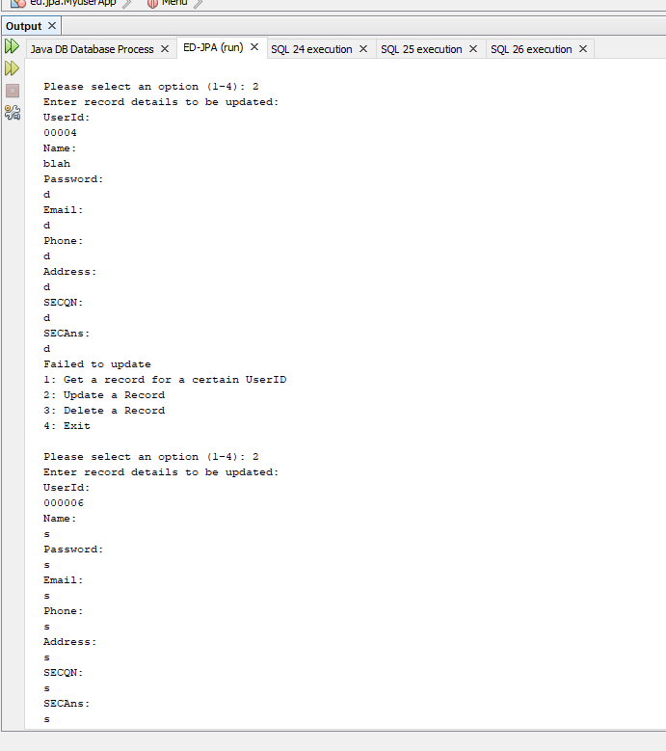

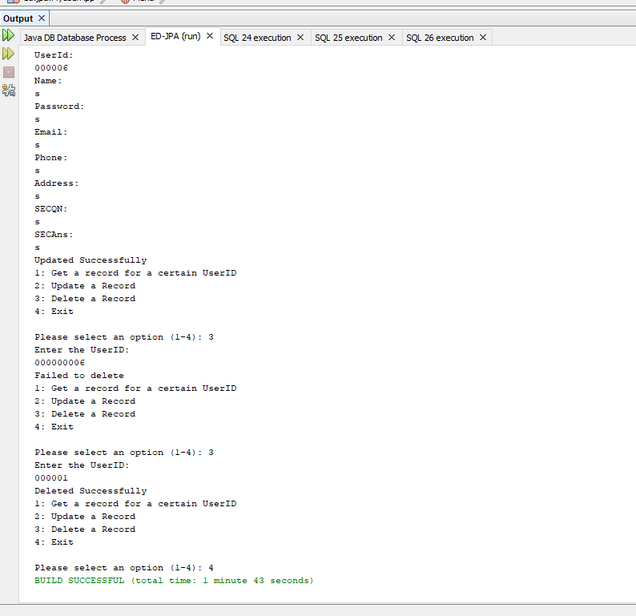

4.1) Here myuser is the DAO object and thus is the one directly accessing the database when the object is created. On the other hand MyuserFacade is just a bean type class. So myuser is responsible for the ORM work

4.2) basically this means that for each session bean, there is always a certain number of bean instances available for use in the pool. So, when a client sends a request, the pool can quickly be used to fulfill the request, and when it’s over, the instance can be returned back to pool for later reuse. So the same bean instance can be used to fulfill the request of lots of clients later on, which in turn make it scalable.